**PROJECT REPORT**

**ON**

**ATTENDANCE MANAGEMENT SYSTEM**

Submitted in Partial Fulfilment of the Requirement

For the award of Degree of

Bachelor of Technology

Computer Science & Technology

By

Ishika Kashyap

2K19CSUN01085

Under the Guidance of

Intrainz



Department of Computer Science & Technology

Manav Rachna University, Faridabad

Month, Year (June 2019)

**ACKNOWLEDGEMENTS**

I would like to express my profound gratitude to Dr . Manpreet Kaur HOD of computer science and technology department, and Dr . Sangeeta Banga Dean of academics for their contributions to the completion of my project titled Attendance Management System.

I would like to express my special thanks to our mentor Dr . Neelu Chaudhary for her time and efforts she provided throughout the year. Intainz’s useful advice and suggestions were really helpful to me during the project’s completion. In this aspect, I am eternally grateful to INTRAINZ for their immense support and guidance throughout the project. Intrainz has provided me a platform to enhance my skills for which I’m grateful.

**CANDIDATE’S DECLARATION**

I hereby declare that work presented in this project report entitled “Attendance Management”, is an authentic record of my own work carried out at Intrainz .

Supervisor Name: Intrainz Student Name: Ishika Kashyap

Signature: Intrainz Signature: Ishika Kashyap

Date: 01-05-2023 Roll No: 2K19CSUN01085

**Abstract**

Student attendance management system deals with the maintenance of the student’s attendance details. It is generates the attendance of the student on basis of presence in class. It is maintained on the daily basis of their attendance. the staffs will be provided with the separate username & password to make the student’s status. The staffs handling the particular subjects responsible to make the attendance for all students. Only if the student present on that particular period, the attendance will be calculated. The students attendance reports based on weekly and consolidate will be generated.

ABSTRACT

The Project titled “Attendance Management System” deal with

the maintainance of attendance details. It is for maintaining daily

basis of Attendance, the staff will be provided with the separate

username and password to make student attendance.

The Staff handling the particular subject to responsible to make

the attendance of all Students.Only if the student present in the

particular date, the attendance will be calculated. The student

attendance report based on monthly and consolidate will be

generated. Here, there is an option to apply for leave and send

the feedback.

The Project titled “Attendance Management System” deal with

the maintainance of attendance details. It is for maintaining daily

basis of Attendance, the staff will be provided with the separate

username and password to make student attendance.

The Staff handling the particular subject to responsible to make

the attendance of all Students.Only if the student present in the

particular date, the attendance will be calculated. The student

attendance report based on monthly and consolidate will be

generated. Here, there is an option to apply for leave and send

thStudent attendance management system deals with the maintenance of the studeattendance details. It generates the attendance of the student on the basis of presence in class. It is maintained on the daily basis of their attendance, the staffs will be provided with

Chapter 1 Introduction

1.1 Objective(s) of the Proposed System

1.2 Present System Description

1.3 Problem definition of the Proposed System

1.4 Hardware and Software Requirements

Chapter 2 Requirements Elicitation and Analysis - Software Requirements Specification (SRS)

2.1 Introduction

2.1.1 Purpose

2.1.2 Scope

2.1.3 Technologies to be used

Chapter 3 Design Specification

3.1 Data Flow Diagram

3.2 Use Case Diagram

3.3 Activity Diagram

3.4 Class Diagram / ER Diagram

3.5 Project Estimation and Implementation Plan

3.6 Input and Output Screen Design Preview

Chapter 4 Coding

4.1 Code/Program Listing

4.2 Algorithm/flowchart

Chapter 5 Conclusions

5.1 Summary

5.2 Limitations of the Project

Future Scope

References

**CHAPTER-1**

**INTRODUCTION**

**1.1 OBJECTIVE:**

“Attendance Management System” is software developed for maintaining the attendance of the student on the daily basis in the college. Here the staffs, who are handling the subjects, will be responsible to mark the attendance of the students. Each staff will be given with a separate user name and password based on the subject they handle. An accurate report based on the student attendance is generated here. This system will also help in evaluating attendance eligibility criteria of a student. Report of the student’s attendance on weekly and monthly basis is generated.

**1.2 PROPOSED SYSTEM:**

To overcome the drawbacks of the existing system, the proposed system has been evolved. This project aims to reduce the paper work and saving time to generate accurate results from the student’s attendance. The system provides with the best user interface. The efficient reports can be generated by using this proposed system.

Advantages of the proposed system:

It is trouble free to use.

It is a relatively fast approach to enter attendance.

It is highly reliable, approximate result from user.

Best user interface.

Efficient reports.

**1.3 Problem Definition:**

To build a cloud based attendance management system to manage the attendance records of students. It will automatically track the attendance of students and generate reports .It stores the details of the students digitally on the cloud. Although manual attendance systems do have some good points but are often at fault.

1.Prone to proxy

2.Human error responsibility

3.Time consuming

4.No review of the eligibility requirements

5.Obsolete system

**SYSTEM SPECIFICATION**

**METHODOLOGY:**

The Project is loaded in Visual Studio. We used Visual Studio for Design and coding of project. Created and maintained all databases into SQL Server, in that we create tables, write query for store data or record of project. Documents were compiled for final output to be submitted to the client. This includes the documentation and software. Giving some user orientation or tutorials on how to use the system is held at this stage.

**1.4 Hardware Requirement:**

* i3 Processor Based Computer or higher
* Memory: 1 GB RAM
* Hard Drive: 50 GB
* Monitor
* Internet Connection

**Software Requirement:**

* Windows 7 or higher
* Visual Studio with C# Language
* SQL SERVER

**CHAPTER-2**

**Project Report**

**On**

**ATTENDANCE MANAGEMENT SYSTEM**

**2.1 INTRODUCTION**

The student attendance management system project used to maintain school students attendance records. The attendance project has two user module for run the system Admin and Student. Initially the system will be blank, The Administrator has a rights to create standard and classroom for school and same time he has to add student details. Administrator generates unique username and password for all staff while adding. All staff maintain attendance of student.

**2.1.1 Purpose:**

The purpose of the project is to provide institutions or organisations with digital monitoring of the attendance of students, employees etc. This software is built to ensure that the attendance monitoring is done digitally so that no proxy is entertained.

**2.1.2 Scope:**

Student Attendance System Modules:

The attendance system asp.net project has main t mowodules.

* Teacher module
* Student module

Admin Functionalities:

* Add students
* Mark attendance
* Add roll no
* Add serial no
* Add location

Student Functionality :

* Manage Account
* Attendance Reports
* Change Password

**2.1.3 Technologies to be used:**

FUNCTIONAL REQUIREMENTS

This defines the function of a system or its component. It deals with what the system should do or provide for users. Functional requirements for this software includes:

The Admin and the Teacher Shall be able to Login into the System using their unique username and password.

The Admin shall be able to add students, teachers, courses, classes, check attendance and validate teacher’s attendance.

The Teacher shall check attendance, generate report of student and manage them.

The attendee shall provide all the necessary registration details.

NON-FUNCTIONAL REQUIREMENTS

Non-Functional requirements are requirements that specifies criteria that can be used to judge the operation of a system, rather than specific behaviours. Non-Functional requirements for this software:

The System Should be easy to use by the Admin, Teachers and students and should be

Organized in a way that user errors are minimized.

The System Should Be Secure from Unauthorized Usage and Access

**CHAPTER-3**

**DESIGN SPECIFICATION**

**3.1 DATA FLOW DIAGRAM**

Context level DFD – 0 level

The context level data flow diagram (dfd) describes the whole system. It shows the all user module who operate the system. The student attendance management system data flow diagram shows there are three users to run the system Admin, Staff and Student.

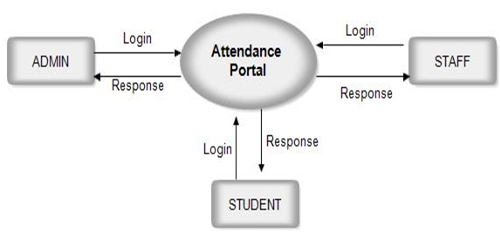

**ADMIN**

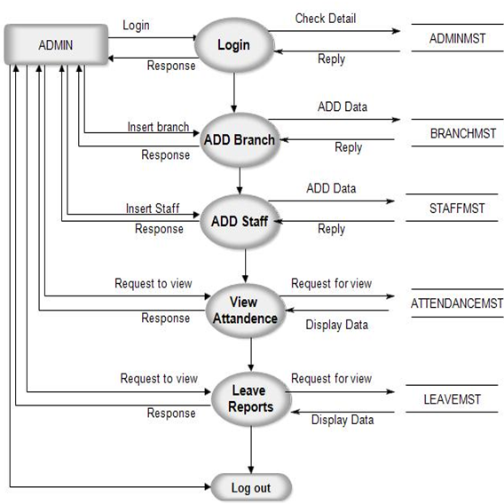

**Student-**

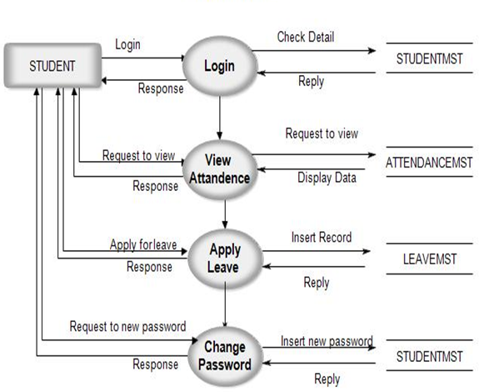

**Staff-**

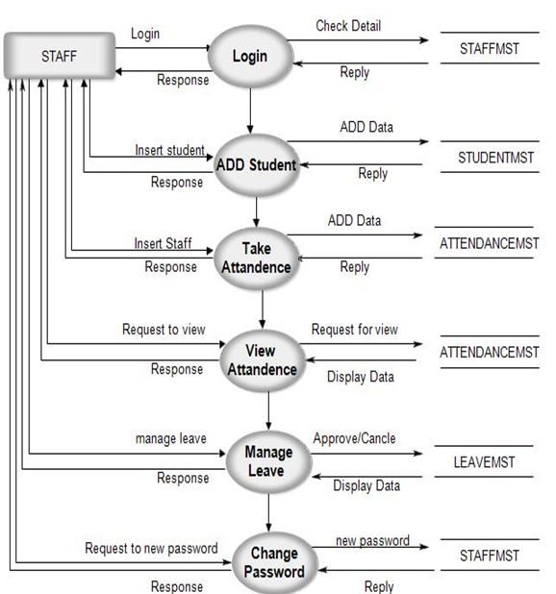

**3.2 USE CASE DIAGRAM**

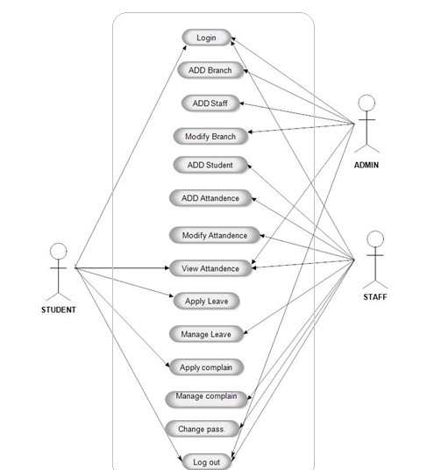

**3.3 ACTIVITY DIAGRAM**

**Admin**

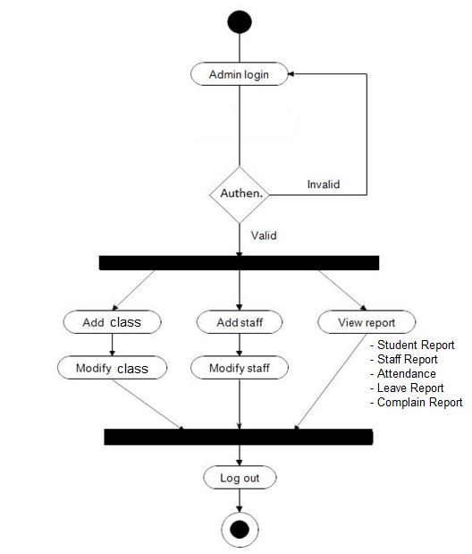

**Student**

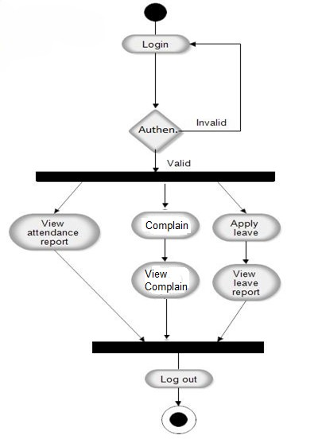

**Staff**

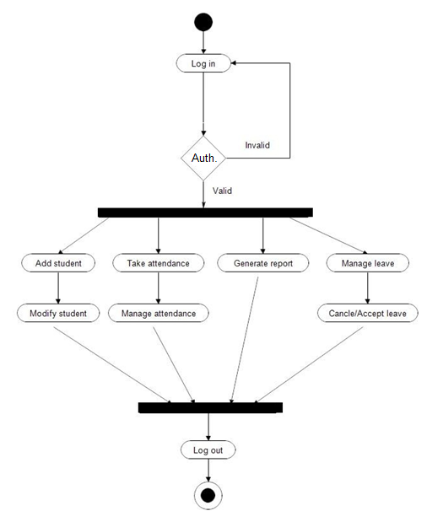

**3.4 E-R DIAGRAM**

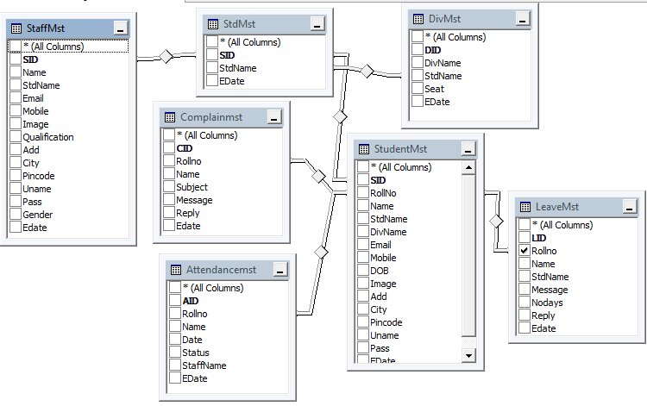

**3.5 FLOW CHART DIAGRAM**

**Admin**

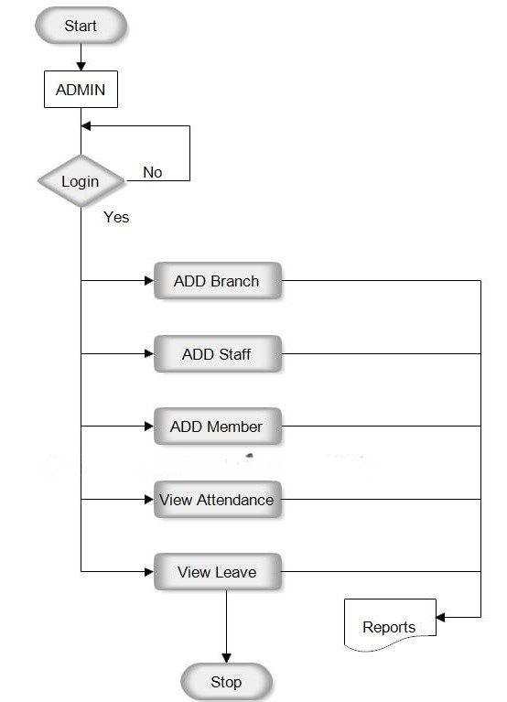

**STUDENT**

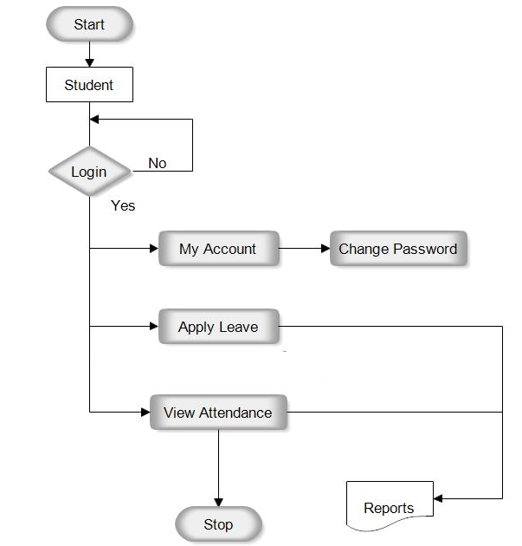

3

**STAFF**

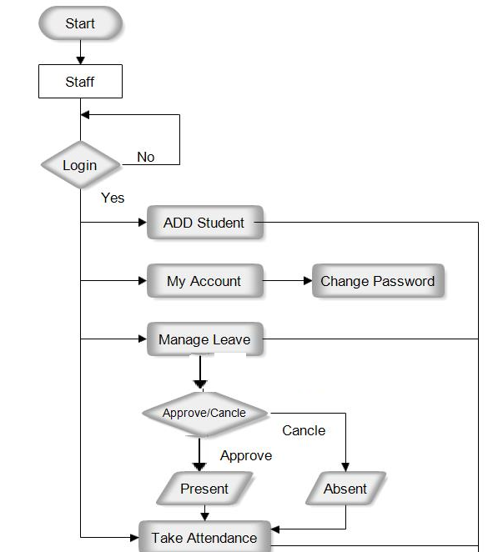

**INPUT AND OUTPUT SCREEN:**

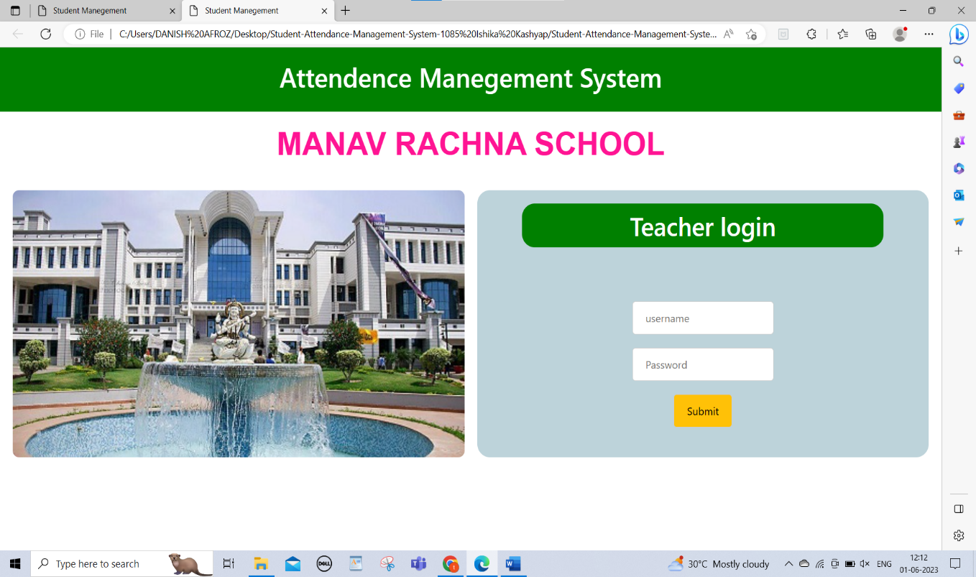

Figure Teacher Login

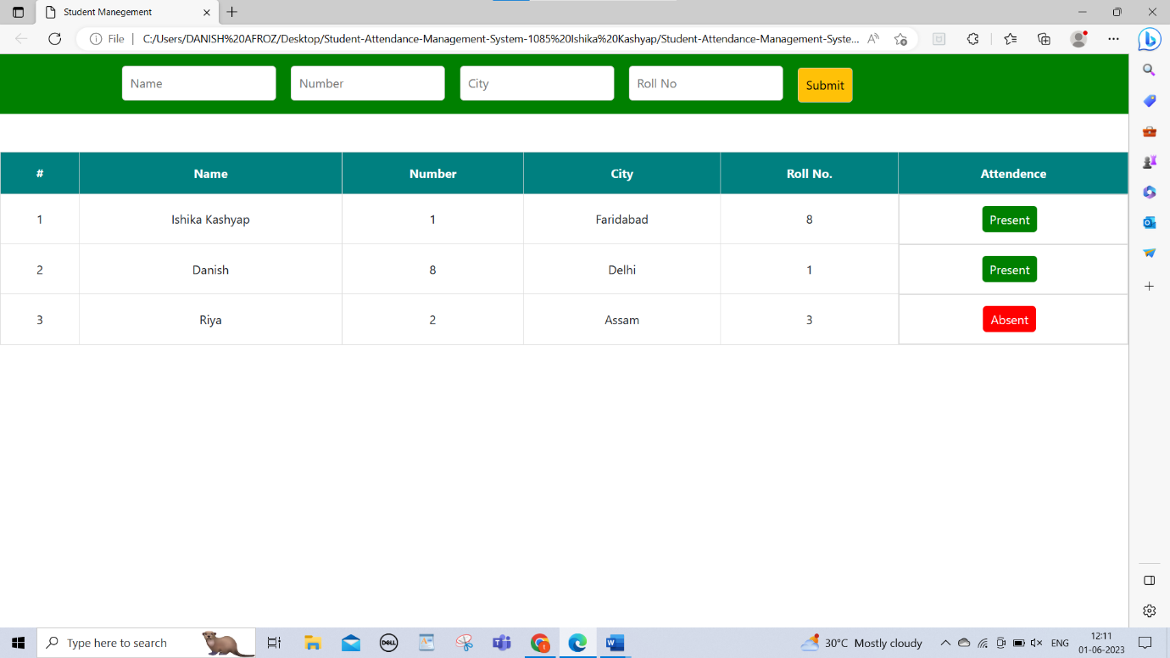

Figure Student Portal

**CHAPTER-4**

**4.1 Code:**

<!doctype html>

<html lang="en">

<head>

<!-- Required meta tags -->

<meta charset="utf-8">

<meta name="viewport" content="width=device-width, initial-scale=1">

<!-- Bootstrap CSS -->

<link href="https://cdn.jsdelivr.net/npm/bootstrap@5.0.2/dist/css/bootstrap.min.css" rel="stylesheet" integrity="sha384-EVSTQN3/azprG1Anm3QDgpJLIm9Nao0Yz1ztcQTwFspd3yD65VohhpuuCOmLASjC" crossorigin="anonymous">

<link rel="stylesheet" href="style.css">

<title>Student Management</title>

</head>

<body>

<div class="heading">

<h1>Attendance Management System</h1>

</div>

<h1 id="school">MANAV RACHNA SCHOOL </h1>

<div class="login" >

<div class="image">

<img src="./R.jfif" alt="">

</div>

<div class="right">

<h2 class="login_head">Teacher login </h2>

<form action="" id="form">

<input type="text" id="name" placeholder="username">

<input type="password" id="password" placeholder="Password">

<input type="submit" class="btn btn-warning" id="submit" value="Submit">

</form>

</div>

</div>

<script src="https://cdn.jsdelivr.net/npm/bootstrap@5.0.2/dist/js/bootstrap.bundle.min.js" integrity="sha384-MrcW6ZMFYlzcLA8Nl+NtUVF0sA7MsXsP1UyJoMp4YLEuNSfAP+JcXn/tWtIaxVXM" crossorigin="anonymous"></script>

<script src="./index.js"></script>

</body>

</html>

**CHAPTER-5**

**CONCLUSION**

**5.1 Summary**

The cloud based Attendance Management and Information System would save funds, improve productivity and aid better administration by providing an efficient tool that receives data, processes it and generates accurate attendance reports in a fast and timely manner.

● The system can be used for schools, colleges, or universities for taking down attendance.

● The system can be used during parents' meetings to show parents about their children's attendance performance.

● It can also be implemented in organizations for attendance.

● It maintains the records in a large database instead of the conventional method of maintaining a register which further simplifies the process of searching for a particular record.

● Admin may easily get the attendance history of a particular student.

● The system introduces a manageable and systematic approach to maintain attendance records.

● No proxy attendance will be entertained.

● It saves user time, cost and institute resources.

● Records can be easily accessed and stored and other information respectively.

● Maintaining the all secured database on the server which will be accessible according to the user requirement without any maintenance cost will be very efficient as compared to storing all the customer data on the spreadsheet or physically in the record b

**5.2 LIMITATIONS OF THE PROJECT:**

* Automatic calculation of leave and reward points accrued
* Automatic teachers and student evaluation about the attendance performance.
* Scheduling of events in the school.

**FUTURE SCOPE:**

Attendance Management System is software developed for daily student attendance in schools, colleges and institutes. It facilitates access to the attendance information of a particular student in a particular class. The information is sorted by the operators, which will be provided by the teacher for a particular class. This system will also help in evaluating attendance eligibility criteria of a student. The purpose of developing attendance management systems is to computerize the traditional way of taking attendance. Another purpose for developing this software is to generate the report automatically at the end of the session or in the between of the session.

**References:**

1. Http Router: https://github.com/juliensclunidt/httprouter
2. Go-pg Library: https://github.com/go-pg/pg
3. SSDP Protocol Specification: https://tools.ietf.org/html/draft-cai-ssdp-v1-03
4. Google Cloud Functions: https://cloud google.com/functions
5. https://www.iitms.co.in/blog/online-attendance-management-software-for-schools.html
6. https://www.quickschools.com/quickschools/features/attendance
7. https://www.vidyalayaschoolsoftware.com/features/student-attendance-management-system

